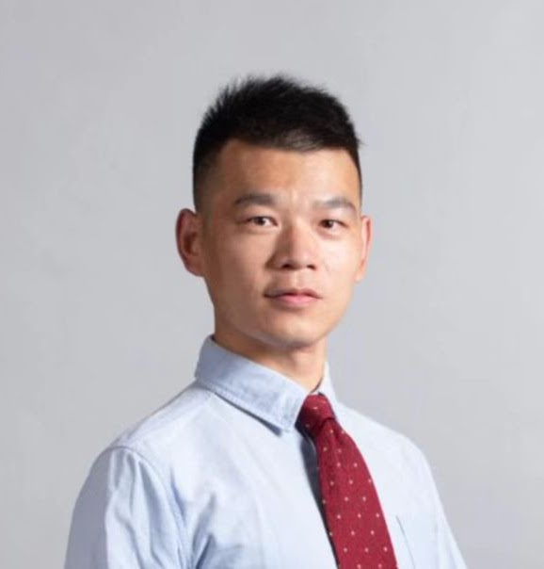**[Semi-Supervised Hierarchical Graph Classification](https://ieeexplore.ieee.org/document/9875050/)**

Jia Li;Yongfeng Huang;Heng Chang;Yu Rong

[IEEE Transactions on Pattern Analysis and Machine Intelligence](https://ieeexplore.ieee.org/xpl/RecentIssue.jsp?punumber=34)

Year: 2022 | Early Access Article | Publisher: IEEE